|  |
| --- |
| Experiment No. 4 |
| Binary Search Algorithm |
| Date of Performance: |
| Date of Submission: |

**Experiment No. 4**

**Title:** Binary Search Algorithm

**Aim:** To study and implement Binary Search Algorithm

**Objective:** To introduce Divide and Conquer based algorithms

**Theory:**

Search a sorted array by repeatedly dividing the search interval in half. Begin with an interval covering the whole array. If the value of the search key is less than the item in the middle of the interval, narrow the interval to the lower half. Otherwise, narrow it to the upper half. Repeatedly check until the value is found or the interval is empty

* Binary search is efficient than linear search. For binary search, the array must be sorted, which is not required in case of linear search.
* It is divide and conquer based search technique.
* In each step the algorithms divides the list into two halves and check if the element to be searched is on upper or lower half the array
* If the element is found, algorithm returns.

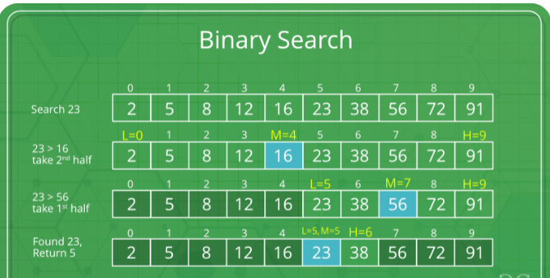

The idea of binary search is to use the information that the array is sorted and reduce the time complexity to O(Log n).

* Compare x with the middle element.
* If x matches with the middle element, we return the mid index.
* Else If x is greater than the mid element, then x can only lie in the right half subarray after the mid element. So we recur for the right half.
* Else (x is smaller) recur for the left half.
* Binary Search reduces search space by half in every iterations. In a linear search, search space was reduced by one only.
* n=elements in the array
* Binary Search would hit the bottom very quickly.

|  |  |  |
| --- | --- | --- |
|  | **Linear Search** | **Binary Search** |
| 2nd iteration | n-1 | n/2 |
| 3rd iteration | n-2 | n/4 |

**Example:**

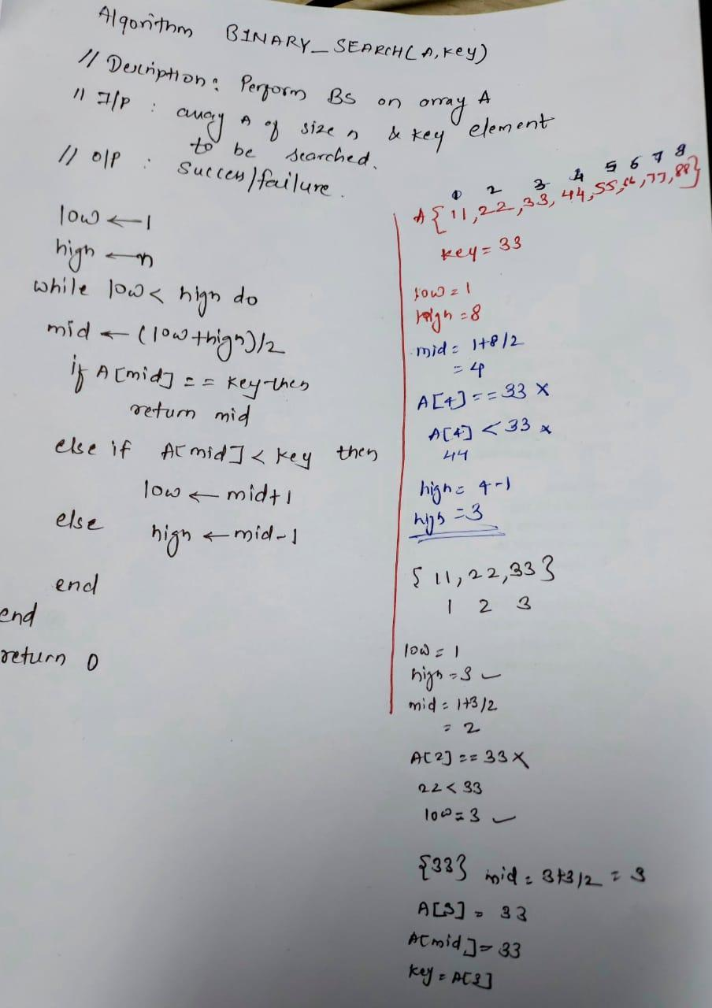

**Algorithm and Complexity:**

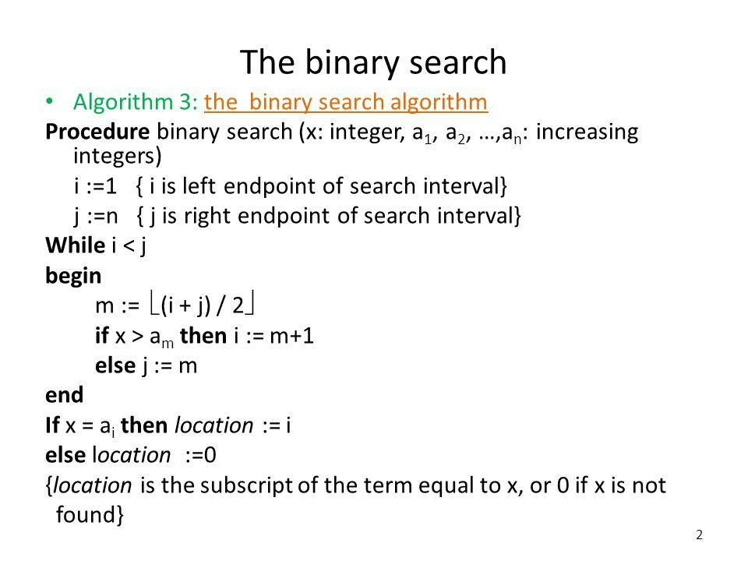

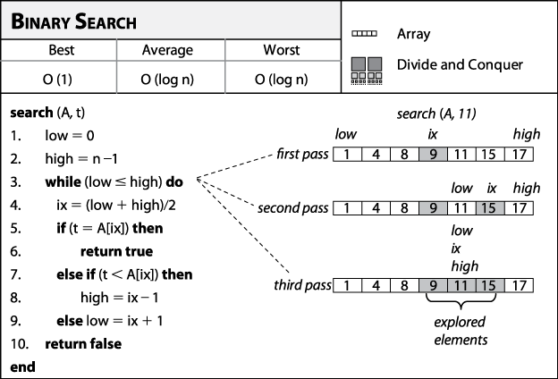

**Best Case:**

Key is first compared with the middle element of the array.

The key is in the middle position of the array, the algorithm does only one comparison, irrespective of the size of the array.

T(n)=1

**Worst Case:**

In each iteration search space of BS is reduced by half, Maximum log n(base 2) array divisions are possible.

Recurrence relation is

T(n)=T(n/2) +1

Running Time is O(logn).

**Average Case:**

Key element neither is in the middle nor at the leaf level of the search tree.

It does half of the log n(base 2).

Base case=O(1)

Average and worst case=O(logn)

**Implementation:**

**Code:**

#include <stdio.h>

#include <conio.h>

int main() {

    int a[] = {11, 22, 33, 44, 55, 66, 77, 88},n = 8;

    int low = 0,high = n - 1;

    int mid,key;

    printf("Enter the element you want to search: ");

    scanf("%d", &key);

    while (low <= high) {

    mid = (low + high) / 2;

    if (a[mid] == key) {

        printf("Element %d is found at index %d\n", key, mid);

        getch();

        return mid;

    } else if (a[mid] < key) {

        low = mid + 1;

    } else {

        high = mid - 1;

    }

    }

    printf("Element %d not found\n", key);

    getch();

    return 0;

}

**Output:**

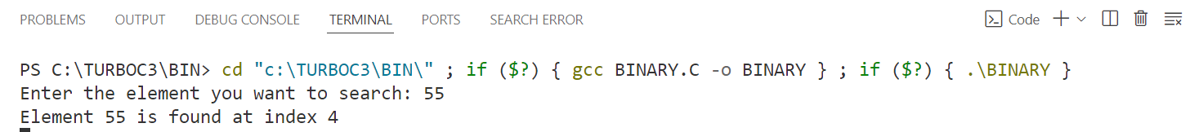

**Conclusion:** In conclusion, the binary search algorithm efficiently locates a target element within a sorted array of integers. This algorithm begins by comparing the target value with the middle element of the array. If they match, the search is successful, and the index of the target element is returned.

If the middle element is smaller than the target, the search continues in the right half of the array, discarding the left half. Conversely, if the middle element is larger than the target, the search moves to the left half of the array, discarding the right half. This process of halving the search space is repeated until the target element is found or the search space is exhausted.

Binary search has a time complexity of O(log n), making it highly efficient for searching large sorted arrays. However, it requires that the array be sorted beforehand, which can add an initial time cost if the array is not already sorted. Despite this prerequisite, binary search is widely used in various applications due to its speed and simplicity.